Developing Strength and Flexibility

Dear Parents, Carers and Gymnasts,

In order for gymnasts to be successful, they must be flexible and developing flexibility is essential to the sport. Good flexibility is beneficial to injury prevention not only in gymnastics but also throughout life. Flexible bodies are typically made, not born. Although strength and flexibility is different from person to person, most people have to work hard to develop proper flexibility throughout their lives. Research shows that a minimum of 30 seconds (and up to 2 minutes) of each stretch, once or twice daily, gives the maximum benefits.

Flexibility must be worked daily, but as our gymnasts are not with us daily, developing flexibility at home is very important. As our gymnasts increase in skills, they need to have increased flexibility to prevent injury and to ensure they perform the skills properly. To gain the right level of flexibility, we recommend our gymnasts work on their flexibility daily at home as well as in the gym.

The stretches each gymnast will be asked to work are easy and safe. It is very important, however, that before any stretching session the muscles are warm from activity. Stretches can be done anywhere, at any time, so long as the muscles are warm. Research shows that stretching with cold muscles can lead to injury. Ten minutes of aerobic activity is usually sufficient to warm up muscles. Aerobic activity can be running, jumping jacks, skipping, or anything that makes the heart have to work and causes the body to warm up.

All stretches should be done without the aid of weights or anyone “pushing” on the gymnast. Gravity, at the lower gymnastics’ levels, is the best “weight” for our young children. As they advance, coaches may assign some more challenging stretches, and these will be communicated to the parent as well as the athlete. However, challenging does not mean painful or harmful.

Strength is another area that requires essential development to reduce injury and support progression within gymnastics. Again, developing strength at home is highly beneficial to the gymnasts and therefore the level they can attain within the sport. Strength work can be done on two or three extra days at home; depending on how many days your gymnast attends a structured class.

Please encourage your young gymnast to complete their ‘home work’, through positive support, to help them understand this is a way of progressing and getting the best out of their gymnastics.

It is our goal that our gymnasts will become more flexible and develop appropriate strength. They will also learn to have personal responsibility for their gymnastics progress through this exercise sheet.
Homework Diary for ______________________________ Date: ____________________

Colour in each box as you do the exercises.

Exercises – 3 days | Monday | Tuesday | Wednesday | Thursday | Friday | Saturday | Sunday
Dish holds
10 seconds x 2 with 10 seconds rest between each hold
Arch holds
10 seconds x 2 with 10 seconds rest between each hold
Side plank hold
10 seconds x 2 with 10 seconds rest between each hold
Each side
Straddle half lever
5 seconds x 2 with 10 seconds rest between each hold
V-sits x 3
X 3 sets with 10 seconds rest between each
Leg lifts high
x 10 each leg - Forward, Sideways, Backwards
Press ups x 5
X 3 sets with 10 seconds rest between each
Plank hold
10 seconds x 2 with 10 seconds rest between each hold
Stretches – Every day
Straddle fold
Piked fold
Forward Splits Right
Forward splits – left
Box splits
Wrist stretch
Shoulder stretch
Bridge hold
Quad stretch
Heel stretch – both feet

Remember:
- Hold each stretch for at least 30 seconds using a timer.
- Don’t bounce
- Stretch only when your muscles are warm
- Breathe normally; DON’T hold the breath.
- Use the best form you can in all exercises and stretches
- Stretching can be uncomfortable, but NOT painful – DON’T go beyond discomfort
- Do your stretches every day
- Your coach may add different stretches for you, don’t forget to do them as well.
- Be responsible. It is your responsibility to remember to exercises, not your parent’s.

Strength Exercises

Dish Hold – Lower/lumbar spine in contact with the floor at all times, feet together, legs straight, chin on chest.

Arch Hold – Feet together (heels and toes), straight legs, straight arms, ears between the arms.

Side Plank Hold – Body in a completely straight line, no tipping forwards or backwards with the hips or shoulders. Legs together and straight, arms straight, lengthening the body as much as possible.
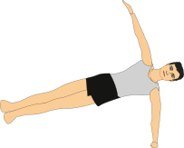

Straddle Half Lever Hold – Straight legs only, feet above hip height, hands in line with knees so that the shoulders are in front of the bottom’s contact with the floor. Hands flat, pushing the floor.

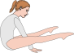

V-Sits – With straight arms and legs throughout, heels and toes pressed together – from lying lift both legs and upper body at the same time to second position, lower slowly to start position.
Leg lifts – forwards, backwards and sideways. BOTH legs remain straight throughout. Working leg with pointed toes, upper body remaining still and in-line throughout. Hips stay straight and in neutral position with all moves.

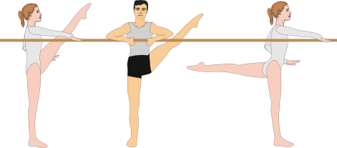

Press ups – Body to remain completely fixed and in line without loss of form throughout. Hands shoulder width apart. Lower to chest touching a bean bag/thick book/weight etc. and then push back to start position.

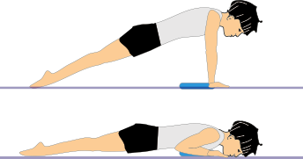

Plank Hold – With body in line and fixed, keep the hold stable thought the count. Legs together and straight, with shoulders over the elbows, head neutral.

STRETCHES
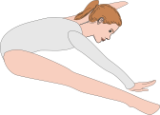
Straddle Fold – Legs straight, arms reaching for the pointed toes, little toes closer to the floor than the big toes, (good turn out), chin reaching forward to reduce the stress in the back and increase the stretch in the legs.

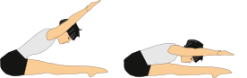
Pike Fold – Arms and legs straight, toes pointed, feet together, chin forwards to increase the stretch in the legs and reduce the stress in the back.

Forward Splits – begin with a correct lunge, legs in line, hips square, shoulders over the hips and head neutral. Rear leg straight with thigh pressing towards the floor, front leg with foot well in front of the knee, knee pointing straight up in line with the foot.

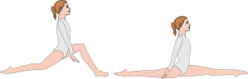

Split position is as above, but the front foot gradually stretches out to straight position. In both positions, keeping the shoulders back is paramount for the correct stretching of the hip flexor. The split should be taken as far as possible without loss of form and then held for the full count in this fixed position, even if the full split is not yet reached; in time, with correct and frequent practice, it will improve.

Box Splits – The best way to practice this at home is for the gymnast to lean on their elbows with tummy and chest facing the floor. Taking the feet as wide as possible, whilst keeping the legs straight, toes pointed and in line with the hips. Tummy should be kept tight to prevent stress on the back.

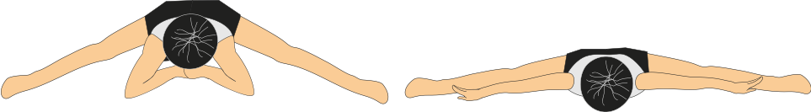

Wrist Stretch – With the hands placed on the floor in front of the kneeling gymnast, turn the hands outwards until the fingers are facing the knees. With straight arms press the heel of the hands down to the floor and hold.
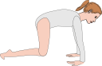

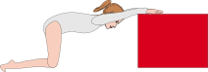
Shoulder Stretch- Kneeling in front of a stool or chair, place straight arms, shoulder width apart, on the surface and press the shoulders and head through the gap. Tummy remains tight and the lower back rounded upwards to ensure the stretch is in the armpits and there is no stress to the lower back.

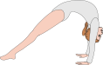
Bridge – Pushing up from the floor, hands must be shoulder width apart, feet together and pressing through the armpit area. The perfect position is with straight legs, pushing the shoulders/chest forwards of the hands, head in neutral. Working towards this position can be done with legs a little bent, or by lifting the feet onto a stable and non-slippy platform, like the bottom step of the stairs; this helps to prevent stress to the lower back.

Quad stretch – Lying on the tummy, bend the knees and bring heels towards the bottom. Holding the heels, press them into the bottom, ensuring the hips stay pressed to the floor.

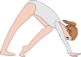
Heel stretch – On hands and toes, hands shoulder width apart, stick the hips high in the air and press one heel closer to the floor; if this is too easy, move the foot backwards until the stretch is felt. Push on the hands to press the heel into the floor, whilst keeping the leg straight and hips high.

